The Four Immeasurables
How to deepen equanimity, love, compassion, and joy.
By Anne C. Klein
FALL 2014
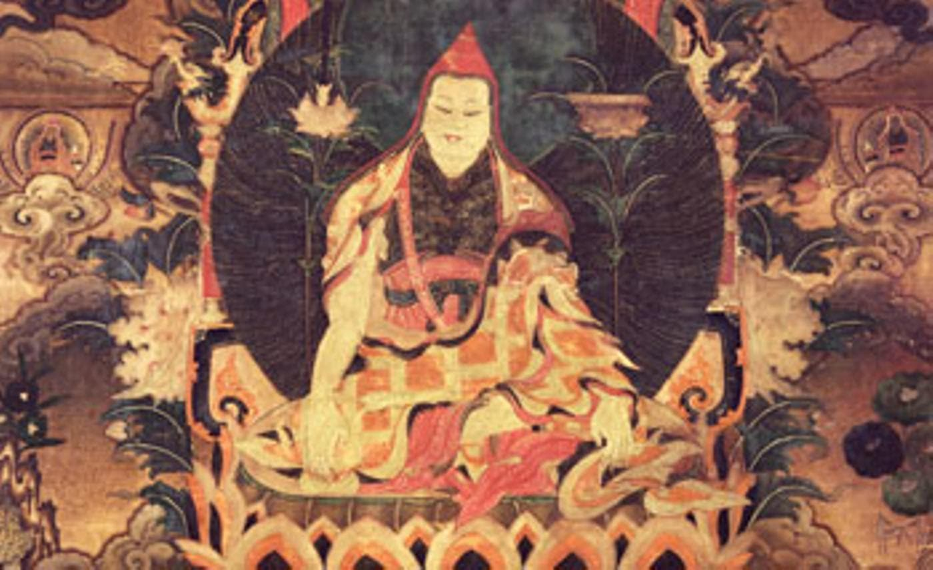Longchenpa Drime Ozer, Tibet, 1800–1899, Nyingma lineage, ground mineral pigment on cotton. Courtesy Rubin Museum of Art.
Buddhism teaches that there is no such thing as the self as we think we know it: a separate, bounded self, strictly cordoned off from what is “other.” When we are freed from the reactive patterns sprung from the boundaries we live by—good and bad; love and hate—we are not the self we were before. And when the boundaries themselves dissolve, self as we understand it disappears.
Buddhist tradition offers two central paths to disestablish our overwrought, constricting sense of self: enlightened love (bodhicitta) and enlightening wisdom (jnana). The four boundless qualities, enumerated in the early canon’s Mettanisamsa Sutta (SN 46.54) as the “four Brahma dwellings,” further both of them. These four boundless qualities, which literally have “no measure” (apramana), are equanimity (upekkha), love (metta), compassion (karuna), and joy (mudita). By dissolving the boundaries that constrain us, these four qualities expand our capacity for experience.
By practicing the four boundless states, we avoid the fate of T. S. Eliot’s poor Alfred Prufrock, who lamented, “I have measured out my life with coffee spoons.” The ease of equanimity, the full-heartedness of love, the tenderness of compassion, the radiance of joy—these are things we don’t want in meager doses. Let us consider them one by one, with an emphasis on equanimity, as it provides the foundation for the other three.
The 4th-century Indian Buddhist philosopher Asanga speaks of two types of equanimity: a meditator’s own equanimity toward all beings and his or her wish that those beings develop equanimity. The former is limitless because equanimity can develop without end. The latter is limitless because beings are limitless. Longchen Rabjam (Longchenpa), the master Nyingma philosopher and practitioner of Dzogchen who wrote in 14th-century Tibet, taught both. A practitioner’s equanimity toward others, he writes, comes from recognizing that everyone seeks happiness.
Tsongkhapa, the revered founder of the Tibetan Gelug order, writing in the late 14th and early 15th centuries, defined equanimity as freedom from powerful reactions, positive or negative, to another person or an event—the ability to be even-minded toward everyone, no matter how they behave. Longchenpa and the 18th-century Nyingma treasure revealer Jigme Lingpa identify equanimity as the portal to two of the five Buddha wisdoms, the special knowing that characterizes fully developed Buddhahood. An antidote to pride, equanimity opens us to the first Buddha wisdom, the wisdom of sameness: this primordial knowing recognizes that everything is suffused by the same true nature—empty, stainless, and unchanging. Equanimity also relaxes the hard hold we have on things. As grasping eases, ignorance itself is undone. Now the practice of equanimity becomes a portal to the second Buddha wisdom, wisdom of the expansive reality known as the stainless real or basic space (dharmadhatu), the true home of everything, which Longchenpa equates with buddhanature.
In the Theravada tradition, the four Brahma dwellings are practices of concentration that culminate in equanimity, which is found only at the fourth level of concentration (jhana), when the mind has moved past the conceptualizing of the lower concentrations. In Mahayana, the four qualities are part of bodhicitta training and begin with equanimity. Just as one must flatten hilly ground to create a stable base for building, so, Tsongkhapa writes, is it vital to even out the mind’s attachment to some persons and disdain for others. Then love and compassion can develop without bias, standing tall and sturdy. Longchenpa and Jigme Lingpa also instruct the beginner to start with equanimity. (The more seasoned practitioner is encouraged to order the four states in accordance with his or her experience.)
With equanimity as their base, the next three boundless states deepen our connection with others. Boundless love, in contrast to clinging and attachment, is the wish for everyone everywhere to have happiness and its causes. It banishes hatred. Love sees everything without distortion, and eventually transforms into the third Buddha wisdom, mirror-like wisdom, which sees everything clearly, just the way it is.
Boundless compassion, which is distinct from being overwhelmed by emotion, is the wish that everyone everywhere be free of pain and its causes. It banishes desire. Tsongkhapa teaches that compassion becomes wisdom when it recognizes the empty nature of those who are suffering. The understanding of cause and effect, according to Jigme Lingpa, gives rise to the all-discerning wisdom that effortlessly knows the details of everything. “Compassion is nothing but the glow and display of emptiness,” says Kangyur Rinpoche in his commentary on Jigme Lingpa’s Treasury of Precious Qualities.
Boundless joy, not to be mistaken for frenzied exultation, is delight in others’ happiness. It banishes jealousy and stabilizes our capacity for engagement. As such, it is a portal to the only remaining Buddha wisdom, the all-accomplishing wisdom that transforms intention into action.
Each boundless quality supports the balance of equanimity. Longchenpa and Jigme Lingpa point out that meditation on love prevents the mind from getting stuck on any of the four states. If love-meditation deviates and furthers attachment, compassion frees us from this suffering. If meditation on compassion is deficient, leading us to feel mired in despair at others’ suffering, we turn attention to joy. If practicing joy incites an agitated yen for more joy, we focus on the great equanimity free of all attachment.
Recognition of our own harmful patterns and our wish to be free from them makes the prospect of cultivating any of these states at once alluring and daunting—daunting because our patterns, harmful though they may be, are at present thoroughly conflated with our sense of who we are. Cultivating each boundless state involves integrating body, mind, emotions, and energies to protect against unhealthy and distorted unbounded states—for example, allowing ourselves to be treated inappropriately by confusing defenselessness for the boundless states that are the goal of these practices. Effective practice proceeds slowly and with care. Gradually, our patterns lose their constricting power, and we live more expansively than before.
With practice—lots of practice!—of the four boundless states, our effort resolves into ease, the self-other divide resolves into wholeness, and ideas resolve into direct experience. The deep ease that practice makes possible furthers our capacity for clarity. What relaxes, ultimately, is the deeply entrenched sense of “being me,” the error that gives rise to all other errors. Freedom from the reactivity created by pride, ignorance, hatred, desire, and jealousy endows an ease of intimacy with our own feelings as well as those of others, and we can live our own stories even while engaging with theirs. No longer dividing the world into good and bad, love and hate, we not only have more freedom and ease in daily life; we also gain access to the wisdom of our real nature.

Anne C. Klein (Rigzin Drolma) is a professor of religious studies at Rice University, a lama in the Nyingma tradition, and a founding teacher at Dawn Mountain Center for Tibetan Buddhism in Houston.

